4-4 Assignment: UI Design

CS 360 Mobile Architect and Programming

Nicholle Caudy

5/28/25

The app I chose is an app that I use when I want to see what my earnings are at any given time within the pay period. We currently must use two different apps when reviewing and adding PTO hours and see what our paycheck amounts are. I think it would benefit employees to see what they have available in PTO and add hours to fill in gaps while seeing how it will affect bring home pay.

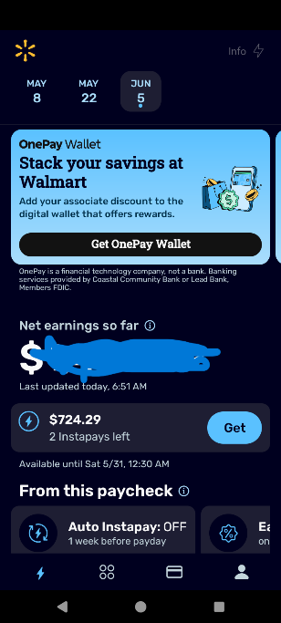

Following the guidelines while redesigning this page for the One@walmart app I made sure to keep the branding style, so users know the company the information is coming from. I added a personalized banner at the top to include the users preferred name; this also allows the user to know that they have the current user information. I included several components using colors that represent Walmart. As a current user of this app and talking to several coworkers I decided to change the layout so that the information you are using the app for (viewing earnings) is the first thing you see. Taking less used options to the bottom of the screen. A dropdown menu was added to allow the user to view the hours worked for each day in the pay period and the earnings per day, enhancing the clarity of the app's functions. In the current version you must press the “net earnings so far” number to see this information and you would not know that unless you just started clicking areas on the screen.

To reduce the need to use multiple apps to see earnings and PTO information I added an informative component allowing the user to see the PTO hours they have available to use. This number will change as the associate uses or gains PTO throughout the year. I also added the function for a user to use their PTO hours to fill in gaps in their hours. This adds to the app’s convenience of use because the user can complete all their payroll needs in one place thus making it far more user-friendly. While adding these elements I followed the guidelines of making the text easy to read and clear to the user. I also used color in the added elements to make the app more appealing to the users and to create separation between actionable items.

I moved the Instapay options under payroll options to create a better flow and still allow the user easy access to this function. I chose to put the OnePay Wallet cards at the bottom of the screen because it is a better layout and this function, although helpful to those who are interested, should not be at the top of the screen. I left the back button, home button, overview button, and navigation tabs at the bottom of the screen as this was the best layout and are what users are comfortable with.

References

[Android Developers - Design for Android opens in new window](https://developer.android.com/design)